

**Module 17**

<https://archive.ics.uci.edu/ml/datasets/bank+marketing>

**Practical Application:**

Visualization - plots/graphs

Modeling - multiple regression models

Findings - write in detail

**Comparing Classifiers**

**Overview:** In this practical application, your goal is to compare the performance of the classifiers we encountered in this section, namely k-Nearest Neighbor, Logistic Regression, Decision Trees, and Support Vector Machines. We will utilize a dataset related to marketing bank products over the telephone.

The input file in data folder!

The assignment of Jupyter notebook for bank marketing campaign model is [bank_marketing.17.Aykan.ipynb](https://github.com/Aykan-Hub/bank-marketing-campaign/blob/main/bank_marketing.17.Aykan.ipynb).

**Getting Started**

Our dataset comes from the UCI Machine Learning repository [link](https://archive.ics.uci.edu/ml/datasets/bank+marketing). The data is from a Portugese banking institution and is a collection of the results of multiple marketing campaigns. We will make use of the article accompanying the dataset [here](https://github.com/Aykan-Hub/bank-marketing-campaign/blob/main/data/bank-additional-names.txt) for more information on the data and features.

**Understanding the Data**

To gain a better understanding of the data, please read the information provided in the [article](https://github.com/Aykan-Hub/bank-marketing-campaign/blob/main/CRISP-DM-BANK.pdf), and examine the Materials and Methods section of the paper.

**How many marketing campaigns does this data represent?**

Answer: "17 campaigns that occurred between May 2008 and November 2010, corresponding to a total of 79354 contacts"

**Data Set Information**

The data is related with direct marketing campaigns of a Portuguese banking institution. The marketing campaigns were based on phone calls. Often, more than one contact to the same client was required, in order to access if the product (bank term deposit) would be ('yes') or not ('no') subscribed.

There are four datasets in the UCI link:

1. [bank-additional-full.csv](https://github.com/Aykan-Hub/bank-marketing-campaign/blob/main/data/bank-additional-full.csv) with all examples (41188) and 20 inputs, ordered by date (from May 2008 to November 2010), very close to the data analyzed in [Moro et al., 2014]
2. bank-additional.csv with 10% of the examples (4119), randomly selected from 1), and 20 inputs.
3. bank-full.csv with all examples and 17 inputs, ordered by date (older version of this dataset with less inputs).
4. bank.csv with 10% of the examples and 17 inputs, randomly selected from 3 (older version of this dataset with less inputs). The smallest datasets are provided to test more computationally demanding machine learning algorithms (e.g., SVM).

**The classification goal is to predict if the client will subscribe (yes/no) a term deposit (variable y).**

**Understanding the Features**

Examine the data description below, and determine if any of the features are missing values or need to be coerced to a different data type.

Input variables:

# bank client data:

1 - age (numeric)

2 - job : type of job (categorical: 'admin.','blue-collar','entrepreneur','housemaid','management','retired','self-employed','services','student','technician','unemployed','unknown')

3 - marital : marital status (categorical: 'divorced','married','single','unknown'; note: 'divorced' means divorced or widowed)

4 - education (categorical: 'basic.4y','basic.6y','basic.9y','high.school','illiterate','professional.course','university.degree','unknown')

5 - default: has credit in default? (categorical: 'no','yes','unknown')

6 - housing: has housing loan? (categorical: 'no','yes','unknown')

7 - loan: has personal loan? (categorical: 'no','yes','unknown')

# related with the last contact of the current campaign:

8 - contact: contact communication type (categorical: 'cellular','telephone')

9 - month: last contact month of year (categorical: 'jan', 'feb', 'mar', ..., 'nov', 'dec')

10 - day_of_week: last contact day of the week (categorical: 'mon','tue','wed','thu','fri')

11 - duration: last contact duration, in seconds (numeric). Important note: this attribute highly affects the output target (e.g., if duration=0 then y='no'). Yet, the duration is not known before a call is performed. Also, after the end of the call y is obviously known. Thus, this input should only be included for benchmark purposes and should be discarded if the intention is to have a realistic predictive model.

# other attributes:

12 - campaign: number of contacts performed during this campaign and for this client (numeric, includes last contact)

13 - pdays: number of days that passed by after the client was last contacted from a previous campaign (numeric; 999 means client was not previously contacted)

14 - previous: number of contacts performed before this campaign and for this client (numeric)

15 - poutcome: outcome of the previous marketing campaign (categorical: 'failure','nonexistent','success')

# social and economic context attributes

16 - emp.var.rate: employment variation rate - quarterly indicator (numeric)

17 - cons.price.idx: consumer price index - monthly indicator (numeric)

18 - cons.conf.idx: consumer confidence index - monthly indicator (numeric)

19 - euribor3m: euribor 3 month rate - daily indicator (numeric)

20 - nr.employed: number of employees - quarterly indicator (numeric)

Output variable (desired target):

21 - y - has the client subscribed a term deposit? (binary: 'yes','no')

**Data Cleaning and Transformation**

There are categorical variables in the dataset, I will transform them before further analyze them.

**Analyze Features**

Some features have *unknown* values, this may impact the models, by checking the feature importance chart, one approach is to assign null to less important features, remove those null tuples from the dataset later on. Especially, day_of_week, loan and housing are at the bottom, I will remove them so no null assignment for them.

|  |  |  |  |  |
| --- | --- | --- | --- | --- |
| **Feature** | **Importance** |  |  |  |
| emp.var.rate | 0.093042 |  |  |  |
| poutcome | 0.047772 |  |  |  |
| cons.conf.idx | 0.026913 |  |  |  |
| contact | 0.005341 |  |  |  |
| default | 0.001988 |  |  |  |
| job | 0.001256 |  |  |  |
| age | 0.000928 |  |  |  |
| month | 0.000579 |  |  |  |
| campaign | 0.000469 |  |  |  |
| marital | 0.000361 |  |  |  |
| housing | 0.000024 |  |  |  |
| loan | 0.000004 |  |  |  |
| day_of_week | -0.000019 |  |  |  |
| education | -0.000128 |  |  |  |

Although, it is shown in the list education seems to have some influence especially in illiterate people's case. So, I will keep it in the list, I can consider dealing with unknown values in later phases.

**Columns Transformations**

**Although, this can be done with encoders, I went with direct transformation since I worked on them to analyze each feature, also, I used them in correlation matrix after the transformation:**

* job is categorical, I used factorize to transform it to numeric
* marital is categorical, I used factorize to transform it to numeric
* education is categorical, I used mapping to transform it to numeric: {'basic.4y':2,'basic.6y':3,'basic.9y':4,'high.school':5,'illiterate':1,'professional.course':6,'university.degree':7,'unknown':0}
* features default, housing and loan have yes/no/unknown values, mapped as: {'no':1,'yes':2,'unknown':0}
* education is categorical, I used mapping to transform it to numeric: {'mon':1,'tue':2,'wed':3,'thu':4,'fri':5}
* poutcome is categorical, I used mapping to transform it to numeric: {'failure':1,'nonexistent':0,'success':2}

**Finally, I transformed the target variable y, yes/no values to 1/0**

**Feature Overlapping**

The subset of data is considered for a baseline model which has only 7 bank-client features: 'age', 'job', 'marital', 'education', 'default', 'housing' and 'loan'. This yields 2085 unique groups of feature overlapping failing to identify yes/no classes in y distinctly. This is effecting 19528 rows in the entire population which is 47% of dataset.

The full dataset has 237 unique groups of feature overlapping failing to identify yes/no classes in y distinctly. This is effecting 3665 rows in the entire population which is 9% of dataset, this is impacting the ability of models to predict outcome for such corner cases.

These observations should be kept in the baseline calculation.

**Features**

Senior people after age 60 accept campaigns more, so do illiterate people, in contrast to that all professions seem to preserve the same ratio!

[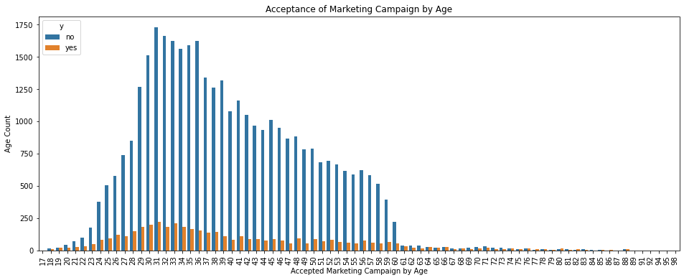](https://github.com/Aykan-Hub/bank-marketing-campaign/blob/main/images/age.png)

**Business Objective**

Due to domestic competition and current financial crisis, there is a huge pressure on European banks to increase financial asset. To overcome this issue, one strategy would be to offer attractive long-term deposit applications with good interest rates, particularly by using directed marketing campaigns. Also, the same economic factors apply for cost reduction and time.

Thus, there is a need for improvement in efficiency: lesser customer contacts must be done, but on the otherhand same success rate must be retained, namely rate of *clients subscribing to the deposit* must be retained.

**A Baseline Model**

Before we build our first model, we want to establish a baseline. What would be the baseline performance that our classifier should aim to beat?

The distribution of target variable shows 89% of observations is No, only 11% is Yes shown in below plot:

[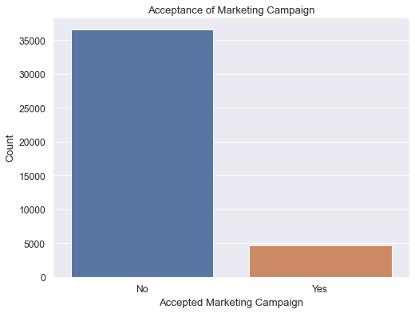](https://github.com/Aykan-Hub/bank-marketing-campaign/blob/main/images/AcceptanceofMarketingCampaign.png)

The baseline is 89% by the target variables outlined in the count plot, the model should be better than this baseline! However, the feature overlapping rate above indicates only 53% can be properly classified, 47% being arbitrarily due to feature overlapping. If we assume 50-50, best we can get is 77% for this dataset as baseline versus simply rely on 89% by the target observations.

After running all 4 models with default hyperparameters, the outcome on recall metric is not very promising, the outcome of Logistic Regression, k-Nearest Neighbors, Decision Tree and Support Vector Machines all performed poorly, there is no outstanding result:

|  |  |  |  |  |
| --- | --- | --- | --- | --- |
| **Model** | **Train Time** | **Train Accuracy** | **Test Accuracy** |  |
| Logistic Regression | 0.013428 | 0.000000 | 0.000000 |  |
| KNN | 0.012411 | 0.126886 | 0.063937 |  |
| Decision Tree | 0.031382 | 0.308901 | 0.099856 |  |
| SVM | 19.583614 | 0.016939 | 0.009339 |  |

The score of Logistic Regression came out as 0.0 and fastest, SVM being the slowest of all.

**Improving the Model**

**Dataset Allocation**

Since all features transformed to numeric representation, a correlation matrix can be checked since there are not many features in the dataset:

[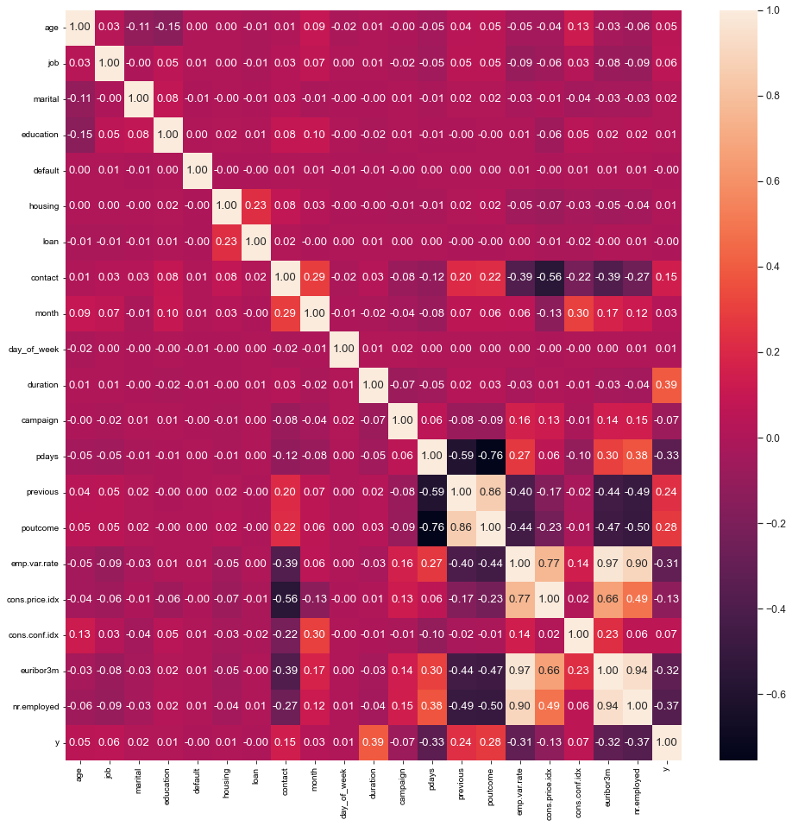](https://github.com/Aykan-Hub/bank-marketing-campaign/blob/main/images/correlationmatrix.png)

Per correlation matrix above, there are some strong correlation among these independent variables which is indicating multicollinearity in the dataset:

* poutcome strongly correlated with pdays (negative) and previous (positive)
* emp.var.rate strongly positive correlated with cons.price.idx, euribor3m and nr.employed I can safely remove those features which are highly correlated above 75%. Later, I would run a multicollinearity analysis on the dataset to verify those findings.

Also, 9% of full dataset cannot be correctly classified as the remaining features on it cannot distinctly define boundaries in the final outcome. Again, if we assume 50-50 distribution, the best outcome will be 95% but realiably accurate outcome is 91% on the full dataset.

Please also note that, duration feature is only known after a call to customer is completed which is an after-the-fact feature, is not available upfront for executing a model. Therefore, it is should be stripped off the dataset.

So these are the features must be removed before proceeding any further with enhanced analysis and model executions: 'duration', 'pdays', 'previous', 'cons.price.idx', 'euribor3m', 'nr.employed'

**Multicollinearity Analysis**

I ran multicollinearity analysis on the remaining dataset, there is nothing above 5 in the list pointing multicollinearity by running Variance Inflation Factor (VIF):

|  |  |
| --- | --- |
| **Feature** | **VIF** |
| emp.var.rate | 1.583261 |
| contact | 1.563009 |
| month | 1.380385 |
| poutcome | 1.280853 |
| cons.conf.idx | 1.271658 |
| default | 1.128615 |
| education | 1.104042 |
| age | 1.092416 |
| housing | 1.063655 |
| loan | 1.055819 |
| marital | 1.028582 |
| campaign | 1.027430 |
| job | 1.014802 |
| day_of_week | 1.001330 |

**Feature Importance**

Also, one more check to complete is feature importance, I ran that too:

|  |  |
| --- | --- |
| **Feature** | **Importance** |
| emp.var.rate | 0.093042 |
| poutcome | 0.047772 |
| cons.conf.idx | 0.026913 |
| contact | 0.005341 |
| default | 0.001988 |
| job | 0.001256 |
| age | 0.000928 |
| month | 0.000579 |
| campaign | 0.000469 |
| marital | 0.000361 |
| housing | 0.000024 |
| loan | 0.000004 |
| day_of_week | -0.000019 |
| education | -0.000128 |

Also, I ran L1 Regularization to see what features picked:

[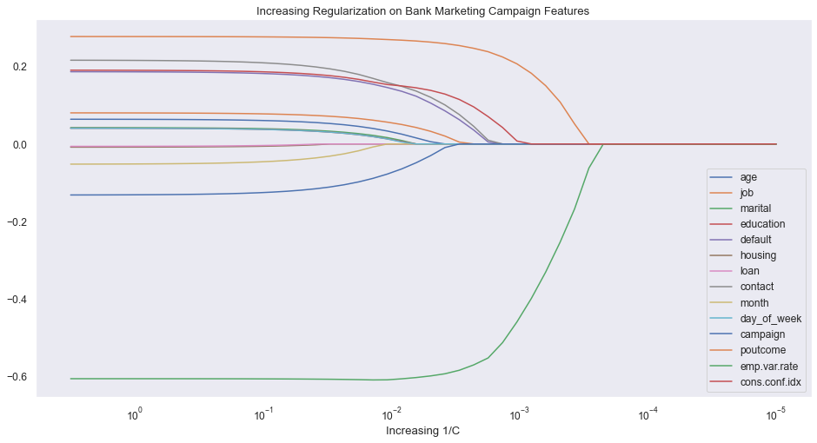](https://github.com/Aykan-Hub/bank-marketing-campaign/blob/main/images/IncreasingRegularizationonBankMarketingCampaignFeatures.png)

Features loan, housing, day_of_week and month seem less important in this plot. loan and day_of_week features are also bottom 2 in the permutation importance list. Also, note education feature is second most important, so, I will not remove that feature.

Further, After the feature engineering methods revealed bottom features, I removed loan, housing, and day_of_week columns and split dataset again. Beyond that, the multicollienarity check by Variance Inflation Factor (VIF) did not point out any features. Going with the scaled dataset after removing 3 less important features from the X dataset, namely: 'loan', 'housing', 'day_of_week'

**SMOTE method**

The dataset is severely imbalanced having 11% acceptance rate and 89% not accepting. Applying SMOTE to have equal number of data entries on either classes of target observation Yes/No.

**Standardization**

Standardization is applied to the dataset in order to avoid small features penalized heavily by the penalty term since features are skewed.

**Model Building**

All 4 models Logistic Regression, k-Nearest Neighbors, Decision Tree and Support Vector Machines were built and fed into GridSearchCV by using roc_auc in scoring hyperparameter since it is binary classification per manual: “A receiver operating characteristic (ROC), or simply ROC curve, is a graphical plot which illustrates the performance of a binary classifier system as its discrimination threshold is varied. It is created by plotting the fraction of true positives out of the positives (TPR = true positive rate) vs. the fraction of false positives out of the negatives (FPR = false positive rate), at various threshold settings. TPR is also known as sensitivity, and FPR is one minus the specificity or true negative rate.”

Each model fed with hyperparameter list to evaluate best outcome, they are captured in a table.

**Model Results**

k-Nearest Neighbors with *91%* is pretty close to our performance metric projection due to feature overlapping. Decision Tree is pretty good too, their train time is pretty close 31 seconds each and reasonable with the magnitude of data. However, Logistic Regression is one click better than Support Vector Machine and fastest train time. SVM took over an hour to train with no parallelism and performed worst in both test accuracy and train time.

|  |  |  |  |  |
| --- | --- | --- | --- | --- |
| **Model** | **Train Time** | **Train Accuracy** | **Test Accuracy** | **Hyperparameters** |
| Logistic Regression | 0.033166 | 0.759782 | 0.763205 | {'C': 100, 'max_iter': 1000, 'solver': 'lbfgs'} |
| k-Nearest Neighbors | 0.030518 | 0.995653 | 0.908220 | {'n_neighbors': 13, 'p': 1, 'weights': 'distance'} |
| Decision Tree | 0.071775 | 0.929373 | 0.891593 | {'criterion': 'entropy', 'max_depth': 33, 'min_samples_leaf': 2, 'min_samples_split': 0.001} |
| Support Vector Machine | 55.611333 | 0.746876 | 0.750658 | {'C': 0.001, 'cache_size': 1000, 'gamma': 0.01, 'kernel': 'rbf'} |

[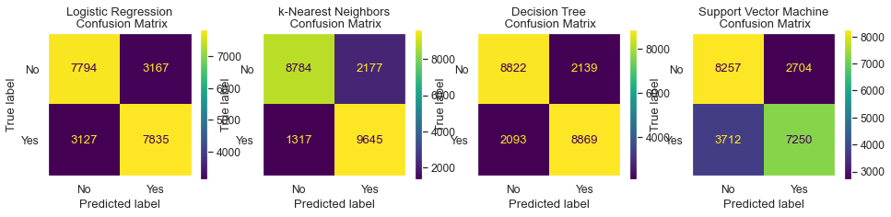](https://github.com/Aykan-Hub/bank-marketing-campaign/blob/main/images/LogisticRegression.png)

The logistic regression came out with a weaker C hyperparameter for regularization and chose lbfgs as solver and being fastest. KNN chose 13 neighbors and best estimator, followed by Decision Tree went with entropy more computationally heavy than gini but train time still less than KNN due to less hyperparameter combinations. Finally, Support Vector Machine came out as the worst performer in both time and score although it picked slightly smaller gamma which is higher dimension also higher bias and smaller variance by C.

As shown in the confusion matrix, KNN has fewer misclassifications, and better area under the curve (AUC) below:

[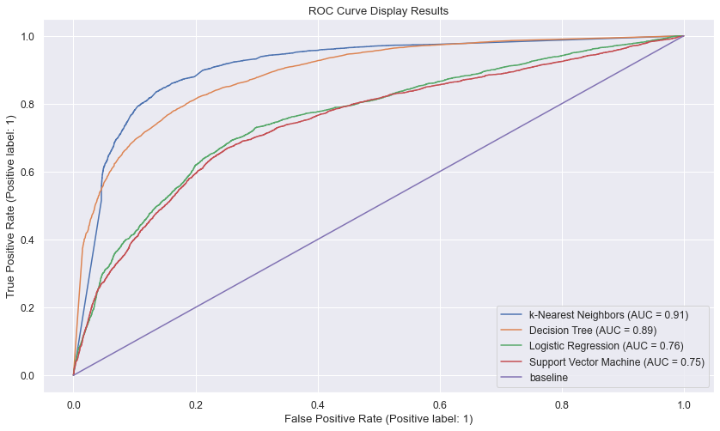](https://github.com/Aykan-Hub/bank-marketing-campaign/blob/main/images/ROCCurveDisplayResults.png)

As shown in Receiver Operating Characteristics curve, the performance of KNN and Decision Tree similar and similarly Logistic Regression and Support Vector Machines.

**Next Steps**

**What are next steps?**

1. I briefly highlighted "unknown" values in categorical variables, job and marital features are highly influential, those unknown values should be removed from the dataset to try out again in those models
2. Secondly, overlapping features should be addressed in the dataset which brings ambiquity to those models, once they are cleared, models should be reevaluated for better performance
3. SVM could be tried with poly kernel and higher degrees, however, it is very CPU-intensive should be on a dedicated computer
4. Logistic Regression with various solver and C hyperparameter values

**Conclusion**

k-Nearest Neighbors came at *91%* outperformed all other models which is inline with my performance metric projection due to the overlapping features. Second best is Decision Tree, its train time is also the second best was 31 seconds. Logistic Regression and Support Vector Machine models are the worst performers. Especially, SVM with no parallelism took over an hour to train the model, it is very costly but yielding not far better results.

KNN is best performing, easy to train and second less costly after Logistic Regression.

repo: <https://github.com/Aykan-Hub/bank-marketing-campaign>

It is worth to check out ROC-AUC explanation: <https://towardsdatascience.com/understanding-auc-roc-curve-68b2303cc9c5>

**Capstone Project**

8/17 - 9/5 schedule meeting with instructors

Finalize problem statement!

Congratulations! You have now completed the three practical application assignments. There will be no further cumulative projects except for your final capstone project.

You should already have proposed a question to answer in your final capstone and looked at possible datasets and techniques. A few modules ago, you should have met with your Learning Facilitator to refine your question and generate ideas for datasets and techniques. Now, it is time to submit the official proposal.

In this discussion board, your initial post should contain the following:

* The research question you intend to answer (one sentence, if possible)
* Your expected data source(s) (either a link to existing data or a sentence describing where you will source the data from)
* The techniques you expect to use in your analysis
* The expected results
* Why this question is important

That last bullet point is the most important. Remember, your final capstone project will be graded not only on the execution of your plan but also on your ability to translate those results into actionable business intelligence that can be acted upon by non-AI/ML personnel. Not only will you have to do the number crunching, but you will also have to distill the results into something understandable by the general public. This last bullet point is your opportunity to explain (in non-AI/ML language) why this question is important. What happens if this question is unanswered? What benefit will your analysis bring?

EDA Analysis

I outlined my **research topic** and proposal below.

**The research question you intend to answer (one sentence, if possible)**

* When clients are interacting with our system, typically they are on happy path but occasionally they deviate from it which may result in negative experience while impacting customer interactions, I would like to predict those negative experiences at any given time by checking past 15 customer interaction data points over 30 days, even if there is more, the set is restricted to most recent 15 actions.

**Your expected data source(s) (either a link to existing data or a sentence describing where you will source the data from)**

* I fabricated such data and defined the data model what would need to look for, represented by columns as below, all features are numeric, interactions are transformed into numerical codes.
* id is a unique identifier per row which bundles interactions together in the row
* *prev_action_15*

through

* *prev_action_1* columns
  + they contain previous interaction codes, from oldest to newest action code: **prev_action_15** being oldest and **prev_action_1** being most recent in the data model representation
  + If there are not enough data points in client interaction history, 0 will be placed in these previous action columns. Please note, semantically, zeros will start appearing from prev_action_15 (from oldest to newest). 0 cannot be on prev_action_1 which means no entry over 30 days for this client!
* **action** is the target column
* Sample data below:

|  |  |  |  |  |  |  |  |  |  |  |  |  |  |  |  |  |
| --- | --- | --- | --- | --- | --- | --- | --- | --- | --- | --- | --- | --- | --- | --- | --- | --- |
| id | prev_action_15 | prev_action_14 | prev_action_13 | prev_action_12 | prev_action_11 | prev_action_10 | prev_action_9 | prev_action_8 | prev_action_7 | prev_action_6 | prev_action_5 | prev_action_4 | prev_action_3 | prev_action_2 | prev_action_1 | action |
| 19059237 | 104 | 158 | 131 | 72 | 179 | 75 | 75 | 73 | 180 | 180 | 179 | 180 | 75 | 55 | 75 | 55 |
| 73879930 | 0 | 0 | 0 | 75 | 77 | 162 | 75 | 75 | 75 | 75 | 75 | 111 | 111 | 55 | 75 | 55 |

Note to the second line entry, there are not enough entries, so, 3 0s in those columns.

**The techniques you expect to use in your analysis**

* This first phase focus is binary classification ,specifically the techniques I would like to utilize are Logistic Regression and Decision Tree.

**The expected results**

* The expected result is predicting **action** column in my dataset and also discover interaction patterns. In the initial phase, my approach will be two models to predict action code = 55 and 142 respectively. Optionally, the next phase will be a multi-class model to predict multi-class action code = 55 and/or 142 with probability as multinomial model but this is not a deal breaker.

**Why this question is important**

* This is a preliminary work in parallel to an ongoing work, I would like to apply the techniques I learnt, see if it helps in anyway to identify those patterns in the dataset, or any improvement point I could bring up comparing my results with the existing. A working classification model is highly desired here to compare its performance with the existing outcome.

**What to use?**

Project: <http://localhost:8888/notebooks/training/capstone/capstone.Aykan.ipynb#>

All Used techniques in <http://localhost:8888/notebooks/training/ML-AI-Education/Berkeley/module12/Try_it_12.1_starter/try_it_12.1.Aykan.ipynb>

Just decision trees: <http://localhost:8888/notebooks/training/ML-AI-Education/Berkeley/module14/try_it_14.2.Aykan.ipynb>

All: <http://localhost:8888/notebooks/training/ML-AI-Education/Berkeley/module16/try-it_16_1_starter/try_it_16.1.Aykan.ipynb#Churn>

Last: <http://localhost:8888/notebooks/training/bank-marketing-campaign/bank_marketing.17.Aykan.ipynb#Apply-SMOTE-method>

It is worth to check out ROC-AUC explanation: <https://towardsdatascience.com/understanding-auc-roc-curve-68b2303cc9c5>

**Notes:**

Making models more interpretable machine learning models: <https://christophm.github.io/interpretable-ml-book/counterfactual.html#counterfactual>

How to understand the outcome of a model

<https://github.com/interpretml/DiCE>

Dataset: <https://github.com/SavioSal/datasets/raw/master/Default.csv>

**Reinforcement Learning**

[Matilde D'Amelio](https://student.emeritus.org/courses/4765/users/166082)

Hi all,

further our discussion on Reinforcement Learning in my last office hour, we would like to share with you the following readings/resources:

1. <http://www.scholarpedia.org/article/Reward_signals>
2. <https://www.science.org/doi/pdf/10.1126/science.275.5306.1593>

Best Regards

Matilde and Savio

**Module Issues:**

**Quizes:**

 ————— o —————